Microsoft Fabric FHIR API Ingestion & Analytics
Detailed Project Documentation
Document purpose: Describe the project architecture, ingestion workflow, data layers, Fabric assets, validation results, and submission considerations.
1. Executive Summary
This project implements a healthcare-data ingestion and processing workflow using Microsoft Fabric and the public HAPI FHIR R4 API. It retrieves Patient, Encounter, Observation, and Condition resources, stores original paginated JSON responses in Lakehouse Files, and organizes processed data across Bronze, Silver, and Gold layers.
The last reported validation snapshot contained 83,913 processed records across the four Silver resource tables. The latest reported pipeline activity status was Succeeded. The user has also confirmed that the existing-record SCD Type 2 test passed. A Power BI report has not been created.
2. Objectives
Ingest selected FHIR resources from a REST API.
Use a two-day lookback for incremental extraction.
Handle API pagination and preserve raw responses.
Process data into Delta-based Bronze and Silver tables.
Provide Gold summary and patient-history structures.
Record metadata useful for tracing ingestion runs.
Validate resource counts and patient-history behavior.
3. Technology and Assets
| Component | Name / configuration |
|---|---|
| Platform | Microsoft Fabric |
| Source | HAPI FHIR R4 public API |
| API base URL | `https://hapi.fhir.org/baseR4` |
| Lakehouse | `LH_FHIR_Healthcare` |
| Production notebook | `NB_FHIR_Production_Ingestion` |
| Additional notebook asset | `NB_FHIR_API_Ingestion` |
| Pipeline | `PL_FHIR_Healthcare_Orchestration` |
| Page size | 100 |
| Incremental lookback | 2 days |
| Resources | Patient, Encounter, Observation, Condition |
4. High-Level Architecture
The logical data flow is:
HAPI FHIR API → Raw JSON in Lakehouse Files → Bronze Delta → Silver Delta → Gold summary / patient history
Raw layer
The production notebook calls each resource endpoint and saves each complete API Bundle response as a JSON file. Files are grouped by resource, load date, and run ID. This preserves the source response and supports troubleshooting or reprocessing.
Example folder pattern:
`Files/raw/{Resource}/load_date={YYYY-MM-DD}/run_id={run_id}/page_{n}.json`
Bronze layer
Raw responses are parsed into structured Delta tables. The incremental Bronze process scans raw runs and merges missing resource IDs into the relevant tables. The known implementation adds missing IDs; do not assume that this specific merge updates all existing IDs unless the executed code explicitly implements that behavior.
Silver layer
Silver tables provide structured, deduplicated resource data for downstream use. The latest reported counts matched the Bronze incremental table counts.
Gold layer
`Gold_Healthcare_Summary` stores a summary by resource, including resource name, total records, and report generation timestamp. `Gold_Patient_History` is used for patient-version history and includes metadata and validity fields.
5. API Ingestion Workflow
The production notebook follows this process:
1. Configure the API base URL, resource list, page size, and lookback window.
2. Calculate the cutoff timestamp in UTC.
3. Request the resource endpoint using `_lastUpdated=ge{cutoff}` and JSON format.
4. Validate the HTTP response.
5. Save each response Bundle to the raw Lakehouse folder.
6. Count entries returned on each page.
7. Follow the API-provided `next` link until no next page remains.
8. Process resources in the sequence Patient, Encounter, Observation, Condition.
9. Print run-level details including resource, run ID, cutoff, pages, records fetched, and output folder.
The API response is saved as a complete Bundle; record counts refer to the entries in those Bundles, not necessarily unique resource IDs.
6. Pipeline Orchestration
`PL_FHIR_Healthcare_Orchestration` contains a Notebook Activity that invokes `NB_FHIR_Production_Ingestion`. Resource iteration occurs inside the notebook.
The latest reported pipeline activity status was **Succeeded**. This establishes successful completion of that notebook activity. It should not be taken as proof that every downstream transformation or Gold refresh ran unless those operations are part of the invoked notebook or separately verified.
7. Data Model and Table Inventory
Bronze tables
`Bronze_Patient_Incremental`
`Bronze_Encounter_Incremental`
`Bronze_Observation_Incremental`
`Bronze_Condition_Incremental`
Silver tables
`Silver_Patient`
`Silver_Encounter`
`Silver_Observation`
`Silver_Condition`
Gold and operational metadata
`Gold_Healthcare_Summary`
`Gold_Patient_History`
`Ingestion_Run_Metadata`
`Ingestion_Run_Metadata` is intended to support resource-level run tracking. Capture the latest rows from the table before final submission so the documented run counts and timestamps align with the actual execution.
8. Validation Snapshot
The last reported processed-table counts were:
| Resource | Count |
|---|---:|
| Patient | 9,192 |
| Encounter | 10,603 |
| Observation | 58,164 |
| Condition | 5,954 |
| **Total** | **83,913** |
The Gold summary was reported to contain the same counts. The summary timestamp previously observed was `2026-10-26 10:45:51.231906`; because this timestamp may be older than a later ingestion run, refresh and recheck the summary before claiming it represents the latest run.
Earlier raw ingestion examples included 3,100 fetched entries on 2026-10-26 and 4,055 on 2026-10-25. Those raw-run entry counts are not the same measure as the accumulated unique Bronze/Silver table counts.
9. Patient History and SCD Type 2
`Gold_Patient_History` includes fields for source/resource identity, extraction metadata, `record_hash`, `is_current`, `valid_from`, and `valid_to`.
The user confirmed that the SCD Type 2 test for changes to an existing Patient record passed. For a strong submission, include sanitized evidence that shows:
the changed Patient ID,
the previous version retained with `is_current = false` and a populated `valid_to`,
the new version with `is_current = true`,
the expected validity timestamps,
exactly one current version for that Patient ID.
A prior baseline validation reported 9,192 history rows, all 9,192 current, zero historical versions, no duplicate current Patient IDs, and no missing IDs between Silver and history. This is an earlier snapshot and should not be used to contradict the subsequently confirmed test; rerun the validation queries after the test and attach the current results.
10. Error Handling and Monitoring
The ingestion notebook uses HTTP response validation, request timeouts, pagination handling, run-specific folders, and notebook progress output. When a run fails, review the pipeline activity details and notebook output to identify the affected resource/page. Capture the failure reason, corrective action, and successful rerun evidence if relevant.
The metadata table should be checked after each run. Retry policy, alerting, and detailed error rows should only be documented as implemented if they are present in the actual Fabric assets.
11. Reporting
No Power BI report has been created as of this documentation version. The Gold summary table is a possible source for an optional report showing resource-level record counts and report generation time. Do not describe a Power BI dashboard as a completed deliverable.
12. Security, Privacy, and Repository Hygiene
Although the endpoint is public, FHIR payloads can contain sensitive or identifiable health information. Do not commit raw patient JSON, patient-level CSV exports, `Gold_Patient_History` data, or backup table data to a public repository. Prefer source code, sanitized schemas, aggregate counts, and screenshots with identifying information removed. Never include access tokens, credentials, or private workspace identifiers.
NB_FHIR_API_Ingestion
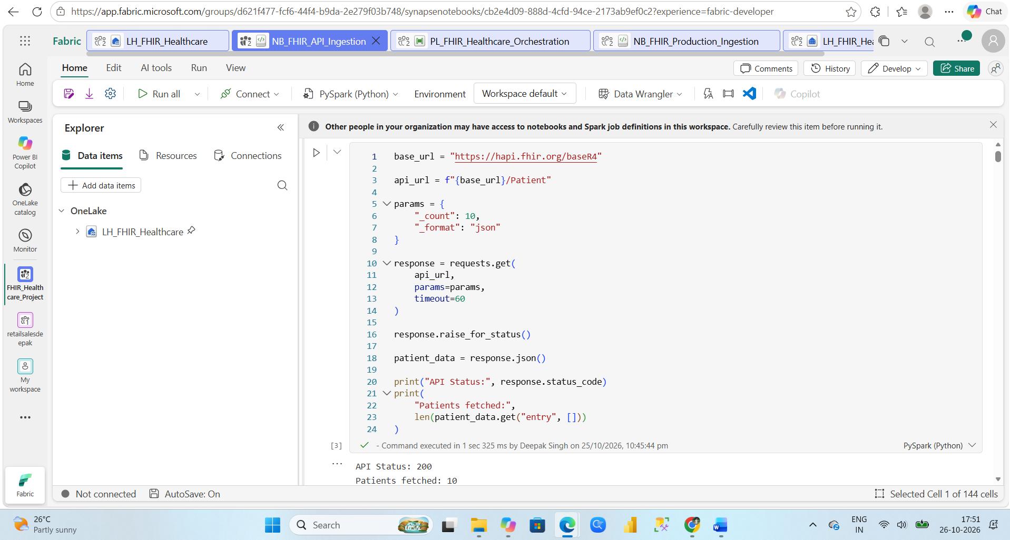
b)NB_FHIR_Production_Ingestion
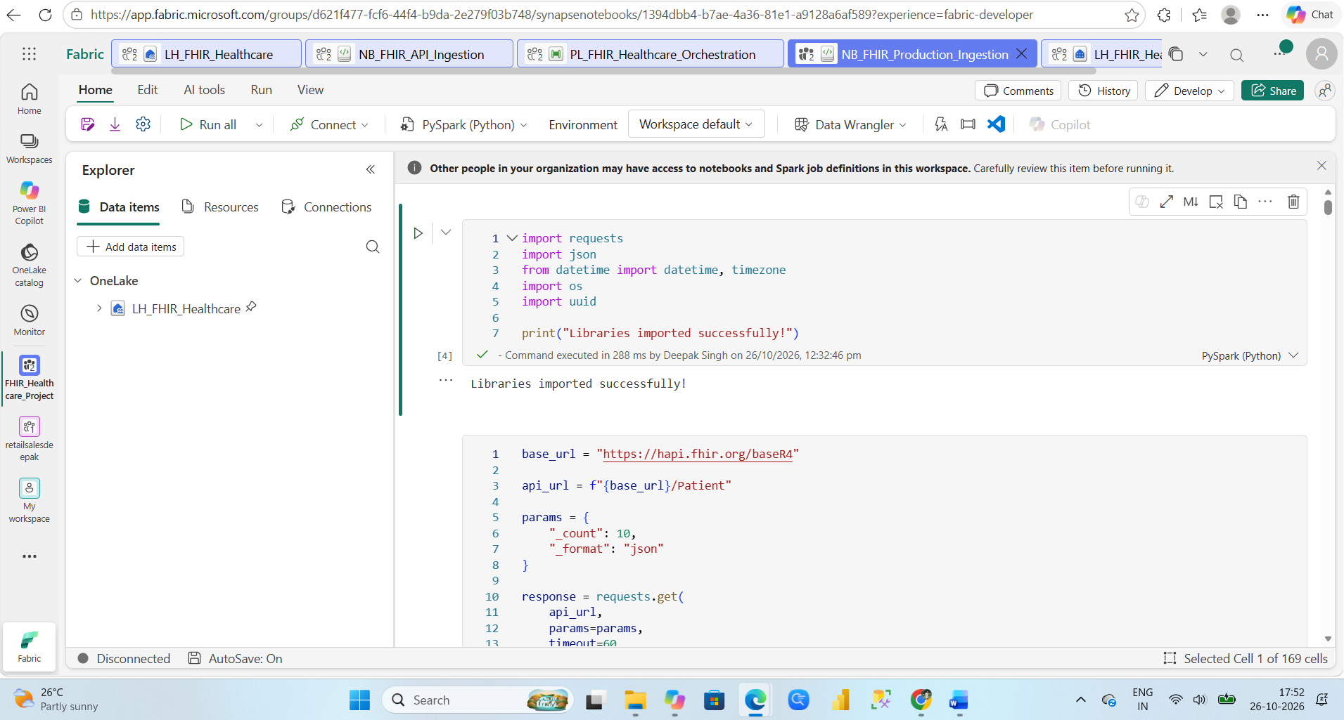
c)Pipeline , it’s took 24 min run time.
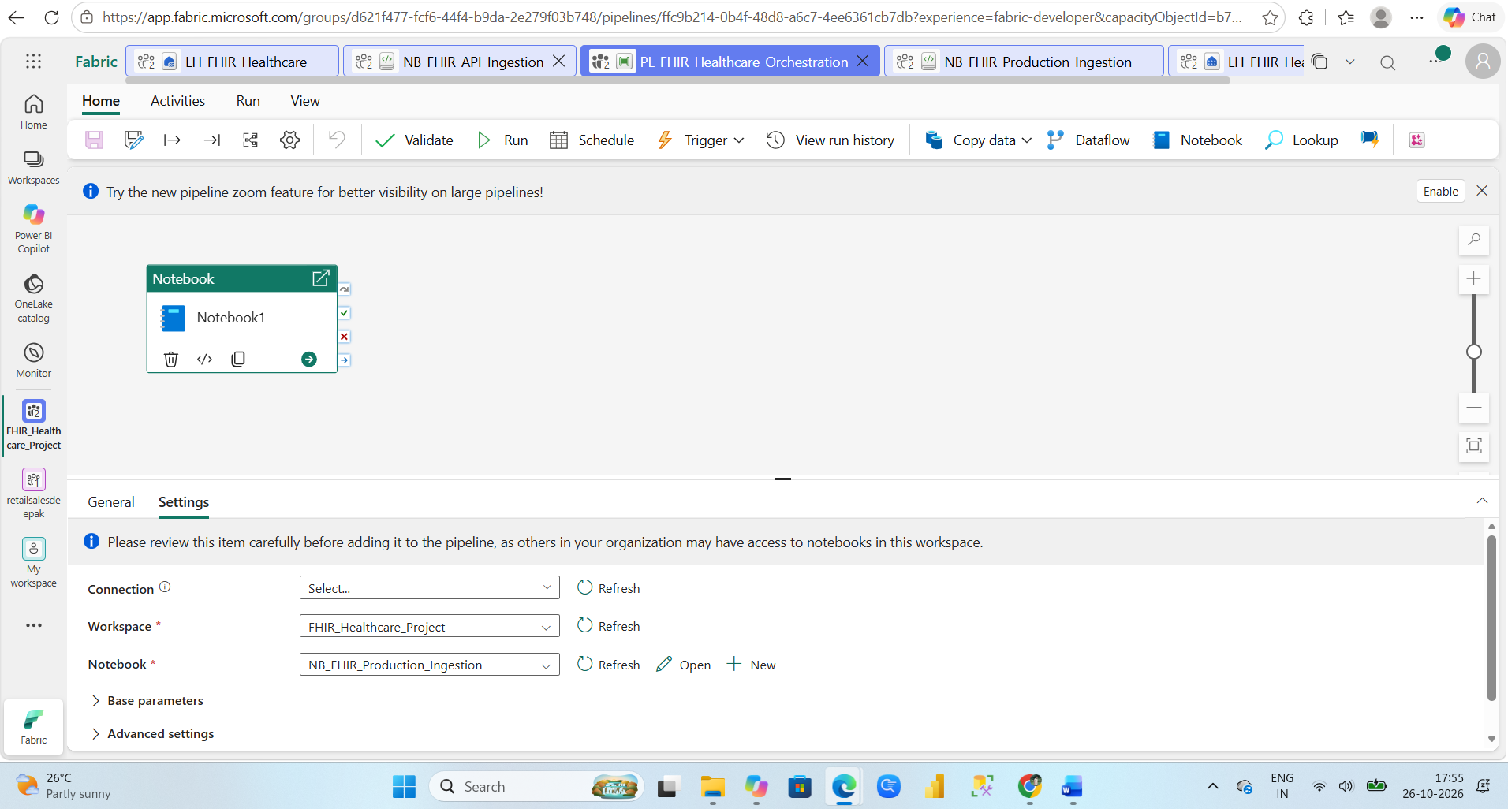
d)Gold_HealthCare_Summary
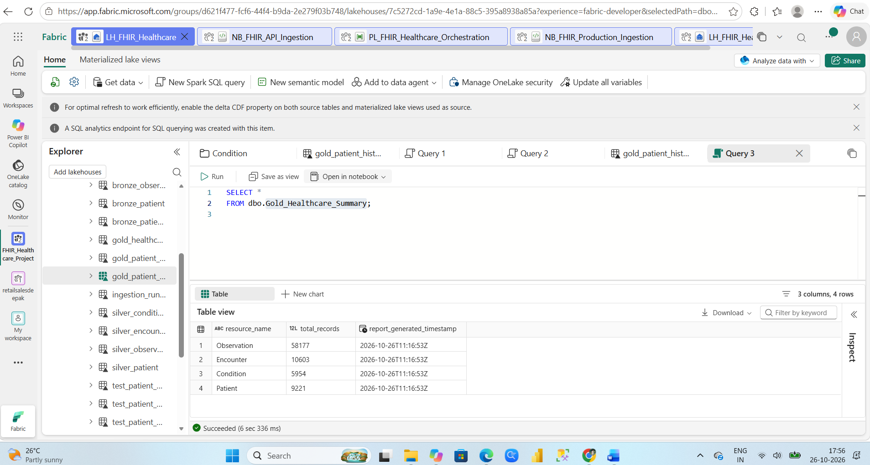
13. Conclusion
The project demonstrates a FHIR API ingestion workflow in Microsoft Fabric with incremental extraction, pagination, raw JSON retention, Delta-based processing, Medallion layers, Gold summary reporting, and patient history management. Based on the latest information provided, the pipeline activity succeeded, the last reported processed-table total was 83,913, and the existing-record SCD Type 2 test passed. Final submission evidence should use refreshed validation results and only the assets actually exported from Fabric.

